**BANK LOAN REPORT - SQL Queries**

1. **Summary Dashboard:**

**Key Performance Indicators (KPIs):**

**Total Loan Applications**

select COUNT(id) as Total_Loan_Applications from bank_loan_data



**MTD Loan Applications**

SELECT COUNT(id) AS MTD_Total_Loan_Applications

FROM bank_loan_data

WHERE MONTH(issue_date) = (

SELECT MAX(MONTH(issue_date)) FROM bank_loan_data

)

AND YEAR(issue_date) = (

SELECT MAX(YEAR(issue_date)) FROM bank_loan_data

)



**PMTD Loan Applications**

SELECT COUNT(id) AS PMTD_Total_Loan_Applications

FROM bank_loan_data

WHERE MONTH(issue_date) = MONTH(DATEADD(month, -1, (SELECT MAX(issue_date) FROM bank_loan_data)))

AND YEAR(issue_date) = (SELECT YEAR(MAX(issue_date)) FROM bank_loan_data)



**Total Funded Amount**

select sum(loan_amount) as Total_Funded_Amount from bank_loan_data



**MTD Total Funded Amount**

select sum(loan_amount) as MTD_Total_Funded_Amount from bank_loan_data

where MONTH(issue_date)=12 and YEAR(issue_date)=2021



**PMTD Total Funded Amount**

select sum(loan_amount) as PMTD_Total_Funded_Amount from bank_loan_data

where MONTH(issue_date)=11 and YEAR(issue_date)=2021



**Total Amount Received**

select sum(total_payment) as Total_Amount_Received from bank_loan_data



**MTD Total Amount Received**

select sum(total_payment) as MTD_Total_Amount_Received from bank_loan_data

where MONTH(issue_date)=12 and YEAR(issue_date)=2021



**PMTD Total Amount Received**

select sum(total_payment) as MTD_Total_Amount_Received from bank_loan_data

where MONTH(issue_date)=11 and YEAR(issue_date)=2021



**Average Interest Rate**

select Round(AVG(int_rate) *100 , 2) as Avg_Interest_Rate

from bank_loan_data



**MTD Average Interest**

select Round(AVG(int_rate) *100 , 2) as MTD_Avg_Interest_Rate

from bank_loan_data

where MONTH(issue_date)=12 and YEAR(issue_date)=2021



**PMTD Average Interest**

select Round(AVG(int_rate) *100 , 2) as MTD_Avg_Interest_Rate

from bank_loan_data

where MONTH(issue_date)=11 and YEAR(issue_date)=2021



**Avg DTI**

select Round(AVG(dti)*100,2) as Avg_DTI from bank_loan_data



**MTD Avg DTI**

select Round(AVG(dti)*100,2) as MTD_Avg_DTI from bank_loan_data

where MONTH(issue_date)=12 and YEAR(issue_date)=2021



**PMTD Avg DTI**

select Round(AVG(dti)*100,2) as PMTD_Avg_DTI from bank_loan_data

where MONTH(issue_date)=11 and YEAR(issue_date)=2021



**GOOD LOAN ISSUED:**

**Good Loan Percentage**

SELECT

(COUNT(CASE WHEN loan_status = 'Fully Paid' OR loan_status = 'Current' THEN id END) * 100) / COUNT(id) AS Good_Loan_Percentage

FROM bank_loan_data



**Good Loan Applications**

select COUNT(CASE WHEN loan_status = 'Fully Paid' OR

loan_status = 'Current' THEN id END)

AS Good_Loan_Applications

FROM bank_loan_data



**Good Loan Funded Amount**

select sum(loan_amount) as Good_Loan_Funded_Amount from bank_loan_data

where loan_status IN ('Fully Paid','Current')



**Good Loan Amount Received**

select sum(total_payment) as Good_Loan_Amount_Received from bank_loan_data

where loan_status IN ('Fully Paid','Current')



**BAD LOAN ISSUED:**

**Bad Loan Percentage**

SELECT

(COUNT(CASE WHEN loan_status = 'Charged Off' THEN id END) * 100.0) /

COUNT(id) AS Bad_Loan_Percentage

FROM bank_loan_data



**Bad Loan Applications**

select COUNT(id) AS Bad_Loan_Applications

FROM bank_loan_data

where loan_status = 'Charged Off'



**Bad Loan Funded Amount**

select sum(loan_amount) as Bad_Loan_Funded_Amount from bank_loan_data

where loan_status = 'Charged Off'



**Bad Loan Amount Received**

select sum(total_payment) as Bad_Loan_Amount_Received from bank_loan_data

where loan_status = 'Charged Off'



**LOAN STATUS:**

SELECT

loan_status,

COUNT(id) AS Total_Loan_Applications,

SUM(total_payment) AS Total_Amount_Received,

SUM(loan_amount) AS Total_Funded_Amount,

AVG(int_rate * 100) AS Interest_Rate,

AVG(dti * 100) AS DTI

FROM

bank_loan_data

GROUP BY

loan_status

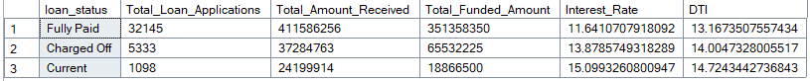

SELECT

loan_status,

SUM(total_payment) AS MTD_Total_Amount_Received,

SUM(loan_amount) AS MTD_Total_Funded_Amount

FROM bank_loan_data

WHERE MONTH(issue_date) = 12

GROUP BY loan_status

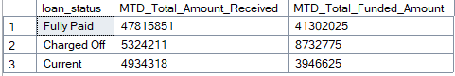

1. **Overview Dashboard:**

**MONTH**

SELECT

MONTH(issue_date) AS Month_Munber,

DATENAME(MONTH, issue_date) AS Month_name,

COUNT(id) AS Total_Loan_Applications,

SUM(loan_amount) AS Total_Funded_Amount,

SUM(total_payment) AS Total_Amount_Received

FROM bank_loan_data

GROUP BY MONTH(issue_date), DATENAME(MONTH, issue_date)

ORDER BY MONTH(issue_date)

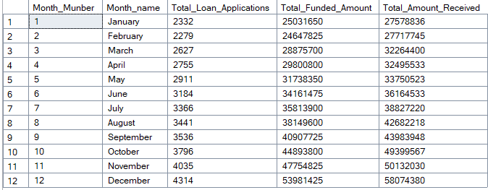

**STATE**

SELECT

address_state,

COUNT(id) AS Total_Loan_Applications,

SUM(loan_amount) AS Total_Funded_Amount,

SUM(total_payment) AS Total_Amount_Received

FROM bank_loan_data

GROUP BY address_state

ORDER BY address_state

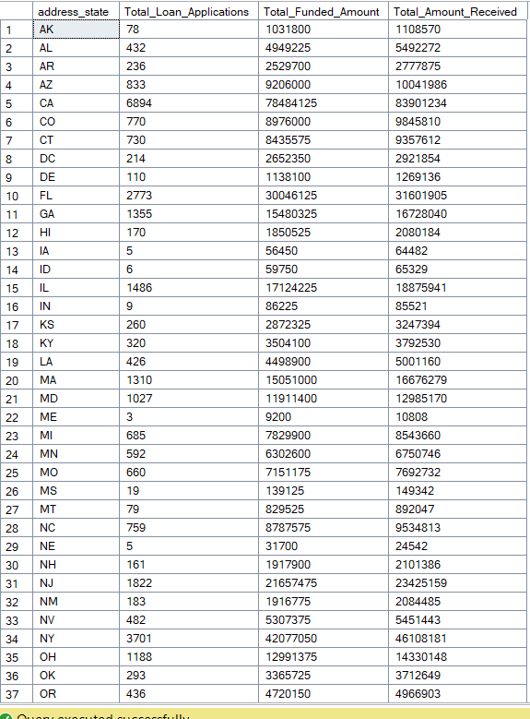

**TERM**

SELECT

term,

COUNT(id) AS Total_Loan_Applications,

SUM(loan_amount) AS Total_Funded_Amount,

SUM(total_payment) AS Total_Amount_Received

FROM bank_loan_data

GROUP BY term

ORDER BY term



**EMPLOYEE LENGTH**

SELECT

emp_length,

COUNT(id) AS Total_Loan_Applications,

SUM(loan_amount) AS Total_Funded_Amount,

SUM(total_payment) AS Total_Amount_Received

FROM bank_loan_data

GROUP BY emp_length

ORDER BY emp_length

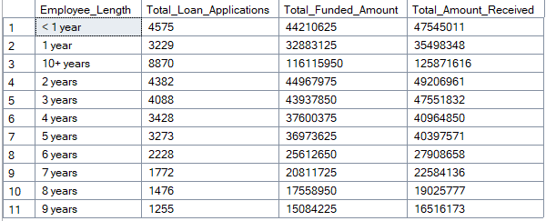

**PURPOSE**

SELECT

purpose as Purpose,

COUNT(id) AS Total_Loan_Applications,

SUM(loan_amount) AS Total_Funded_Amount,

SUM(total_payment) AS Total_Amount_Received

FROM bank_loan_data

GROUP BY purpose

ORDER BY purpose

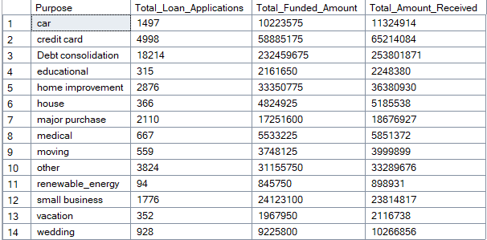

**HOME OWNERSHIP**

SELECT

home_ownership,

COUNT(id) AS Total_Loan_Applications,

SUM(loan_amount) AS Total_Funded_Amount,

SUM(total_payment) AS Total_Amount_Received

FROM bank_loan_data

GROUP BY home_ownership

ORDER BY COUNT(id) DESC

